Scrumptious Personal Financial Website
Software Design Document

Scrumptious
Scrumptious Personal financial Website

2nd March 2018
Version 1.0

______________________________
[Project Lead Signature Block]

______________________________
[Project Manager Signature Block]

TABLE CONTENTS
Introduction 3
1.1 Purpose 3
1.2 Scope 3
2 Design Overview 4
2.1 Background Information 4
2.2 Alternatives 4
3 User Characteristics 4
4 Requirements and Constraints 5
4.1 Performance Requirements 5
4.2 Security Requirements 5
4.3 Design Constraints 5
5 System Architecture 5
6 Detailed Design 7
7 Data Architecture 7
7.1 Logical Database Model 7
7.2 Data Conversion 8
8 Interface Requirements 8
8.1 Required Interfaces 8
9 User Interface 8
9.1 [Module X] Interface Design 8
10 Non-Functional Requirements 11
10.1 Performance Requirements 11
10.2 Security Requirements 11
10.3 Software Quality Attributes 11

Introduction

This document will serve as the official design documentation for the Scrumptious financial application website. The overarching goal of the project is to create a website that helps users effectively manage their finances.

Purpose
This Software design document is intended to describe the overall design of the website primarily to a developer who would like to understand how the website was designed. However this document will also be applicable for a general user simply interested in the design of the website as the technical language used is minimal.

Scope
The software products in reference within this document is the Scrumptious financial website.
The product will enable users to view and track their finances and also send and receive money from other website users.

This software will interface with user’s personal comupters, tablets or phones. It must therefore be quite versatile to be used on a varety of devices and web browsers.
This Document may evolve quite substantially during this development cycle as with each new iteration of the website new features may be added/ removed and therefore the final version may have some fairly significant differences from this initial version.
The goals of this project are:
- To provide a simple and straightforward website to be used by people aged 16-30 with little or no financial/technical knowledge.
- To provide a platform where users can clearly view their finances and manage their use of money
- To provide a platform that enables users to send and receive money form other users.
The product is built using HTML, Javascript and CSS from the front end and uses SQL in the back end to manage the database of user accounts and user details.

Design Overview

Background Information
[This section should briefly present background information relevant to the development of the system design. All stakeholders should be identified and their contact information provided. A description of associated project risks and issues may also be presented along with assumptions and dependencies critical to project success. Describe the business processes that will be modeled by the system. ]

Alternatives
The project was initially began as a mobile application though after consultation with the client this was changed to begin with a website. A major reason for this was to provide more flexibility as the users of the software may want to use it from a variety of devices and not simply a mobile phone.

User Characteristics
The 3 main users that shall use this product will be composed of include: general users, administrators and financial institutions.
The ‘general users’ class is quite general and refers to anyone who uses the website for the general management of their personal finances. This will be people between 16-30 who are either just learning how to manage their finances or have some experience managing their finances.They should be able to view their account balances and transactions; send money from one account to another and have contact information to their financial services account.
To meet the requirements of these users the website will need to be easy and simple to use and will need to be able to work simply on a variety of devices.

The Financial account class should have the ability to provide information on current products/services being offered and offer users financial assistance through the website platform. The users will be the only ones with the ability to view all their transactions and user balances.
In regard to these users the website will need to be simple and easy to use clearly showing the information they can and have sent to their customers on the website.

The Administrators will have the ability to manage user accounts by modifying the site and approving significant changes e.g. closing the account or closing an account with a financial institution.

Requirements and Constraints

Performance Requirements
The major performance requirement for this application is for it to ensure secure storage of each user’s information and provide the ability for the users to securely send money through the platform to another financial institution.

The Website shall also need to ensure that the user’s transaction data is updated and current by regularly refreshing data on the current account balances and transactions and prompting the user to upload .csv bank statements.

Security Requirements
Security is a very important aspect of this application and must therefore be treated as such. The two main aspects of this will be: user identification and secure storage of user data.
Regarding user identification, currently the website uses a password to protect user data though later revisions will look towards implementing two factor authentication using either a one-time access code or biometric authentication. This security feature will therefore ensure that the user’s identity is verified before they can access any information.
In terms of Data storage, all data will be encrypted and stored on the server for maximum security.

Design Constraints
Some design constraints include variability in the browser used/device used to view the product. To address this the design will use a ‘graceful degredation’ approach to ensure that it is usable on a variety of devices. During the design process a variety of devices will be used to test the website however this will be limited to the devices currently on had due to budget constraints.
Time will be another constraint on the design of this website. As the project duration is limited to 1 month the time we have for designing is limited. We shall therefore focus on the core design components before branching off to the smaller design attributes.

System Architecture

The overall system architecture design is provided diagrammatically below through the use of sequence diagrams. These illustrate the processes that users go through when navigating and using the websits and this provide an overview of the website design at a high level.

Register User Sequence diagram
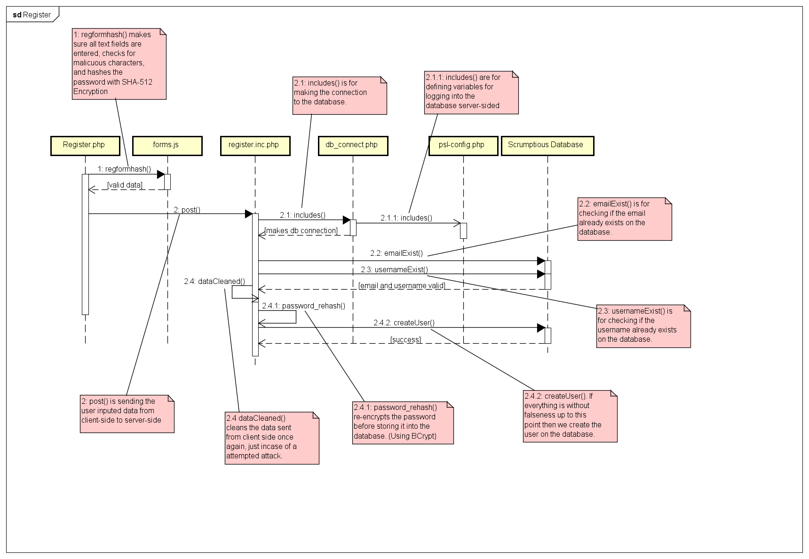
Transaction process sequence diagram
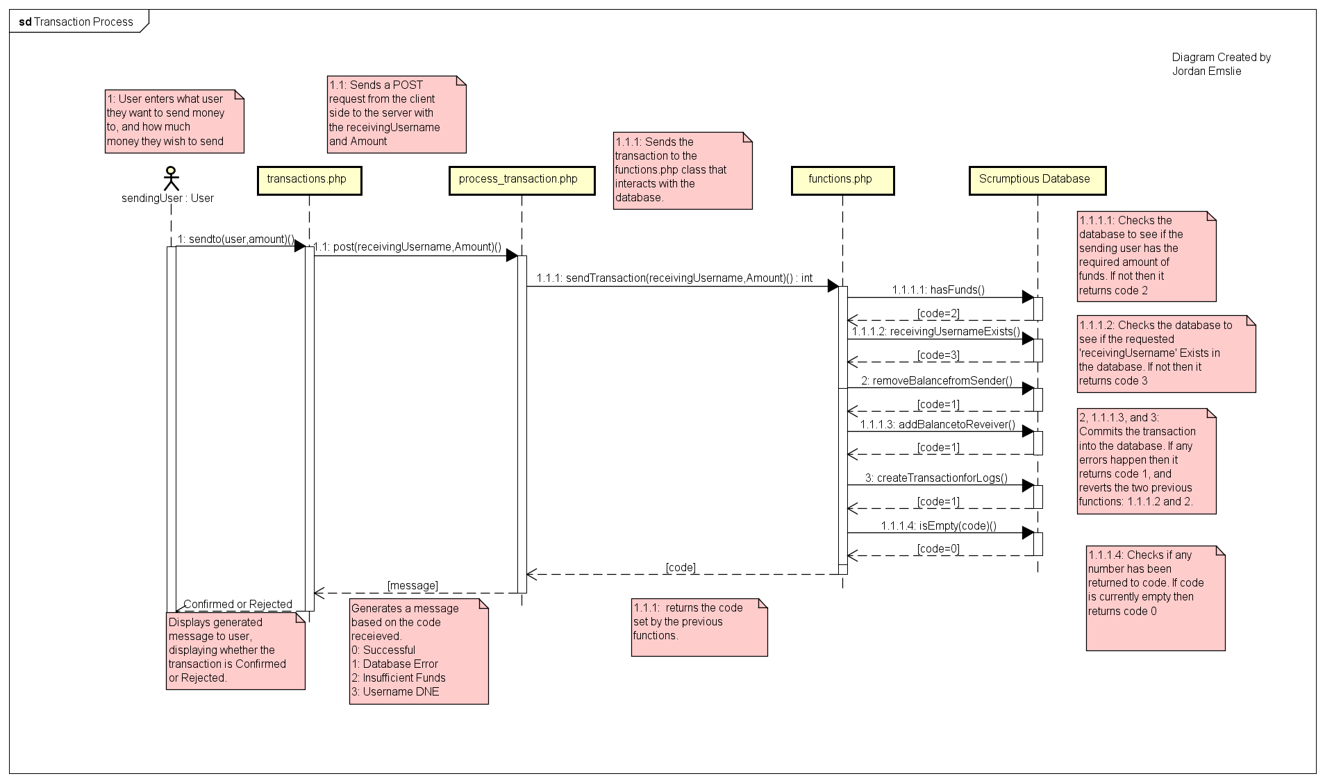

Detailed Design
The main components of this design are HTML, php and CSS pages which interact and enable the website to fully function. The php pages will have embedded SQL code which will be used to query and update the SQL database for user information.
The ‘register’ html file will take in the details of each user and use these to create a new entry in the users SQL table.
The overview/homepage will provide information on notifications and general financial information to the user.
The transactions page will show the transactions that the user has made for each account profile they have. This will work by pulling data from the sql account table for each user.

Data Architecture
The data structures used in this software are SQL relational tables. These are used to store user data and account transaction data. ‘php’ files have embedded SQL queries which allows them to query and update the SQL tables. A summary of these relational tables is provided in the UML diagram below.

Logical Database Model
The database for this project is described by 4 relational tables which each store user data. The relational tables include: Transaction, Wallet, User, Account and AccountTransaction. An overview of these and their relationships is summarized in the UML diagram below.
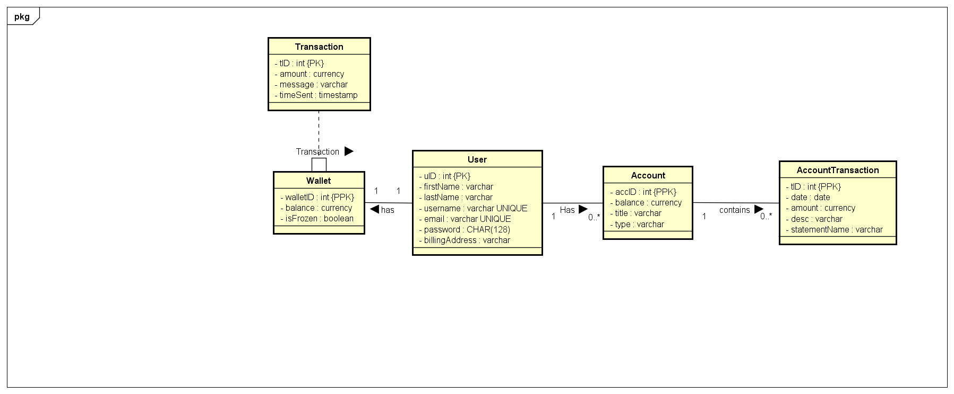

Data Conversion
The data conversion implemented in this software will be a straight-forward conversion of a .csv bank statement to a an SQL bank account table. The bank account table will need to be able to amalgamate data from several.csv files and present this to the user as a summary of their financial account.

Interface Requirements

Required Interfaces
TBD
The main interface will be the user screen on the device (Phone, tablet, PC…) that they use to access the website. The design for this will need to take into account the possibility of a touchscreen use vs a mouse/keyboard use.

User Interface
The User interface is made up of several interlinked pages:
- The register page which should allow the user to create a new account on the scrumptious website. The data to be entered by the user includes: Username, first name, last name, password, email and address
- The login page which allows the user to login to their account by providing a username and password
- The user homepage which gives updates and reminders
- An ‘Add Account’ page which allows the user to create a profile for one of their financial accounts on the website platform it requires: the title of the account, the financial institution it is linked with, the account type and the balance.
- A Transactions page which shows the current transactions made for each account and links them to a category e.g. food, clothes.
- A calendar page which helps users to keep track of upcoming payments/salaries

[Module X] Interface Design

Account register page
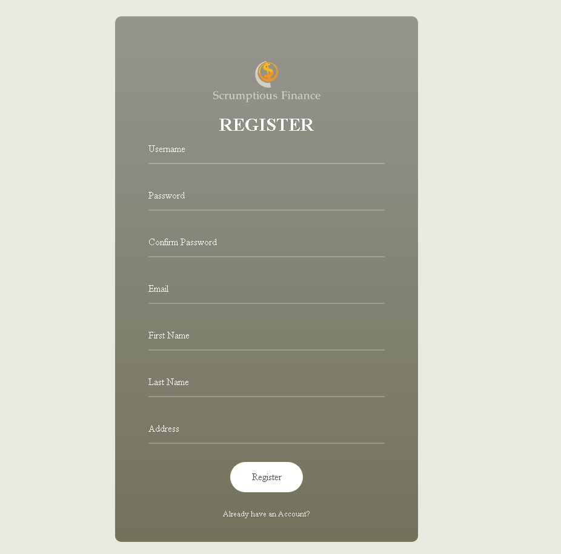
Login page
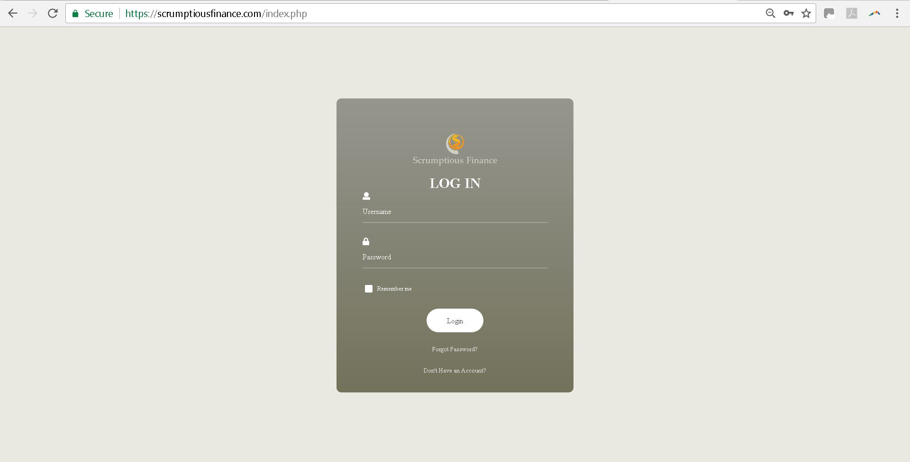

Overview/homepage
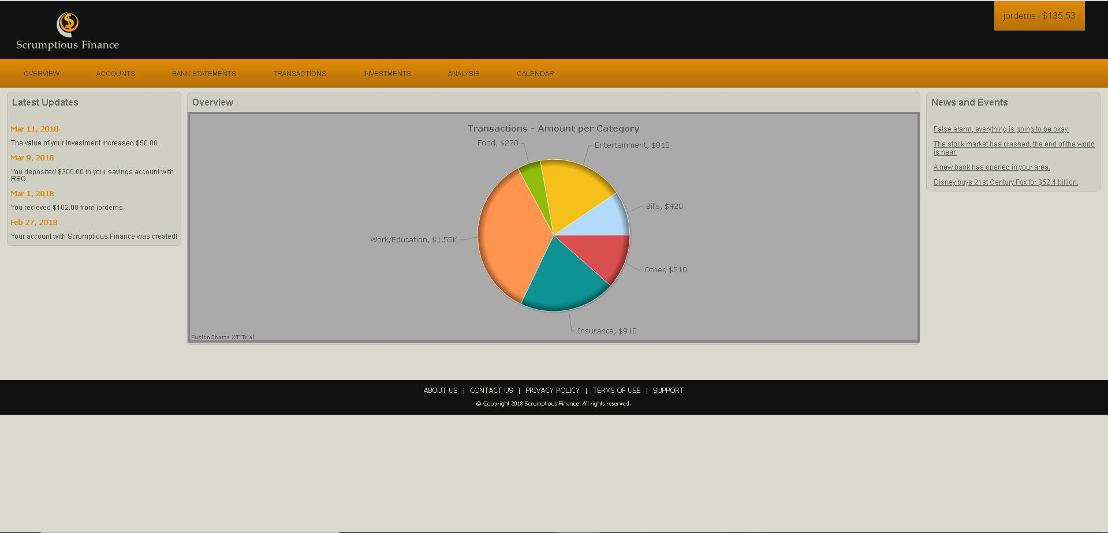

Accounts page
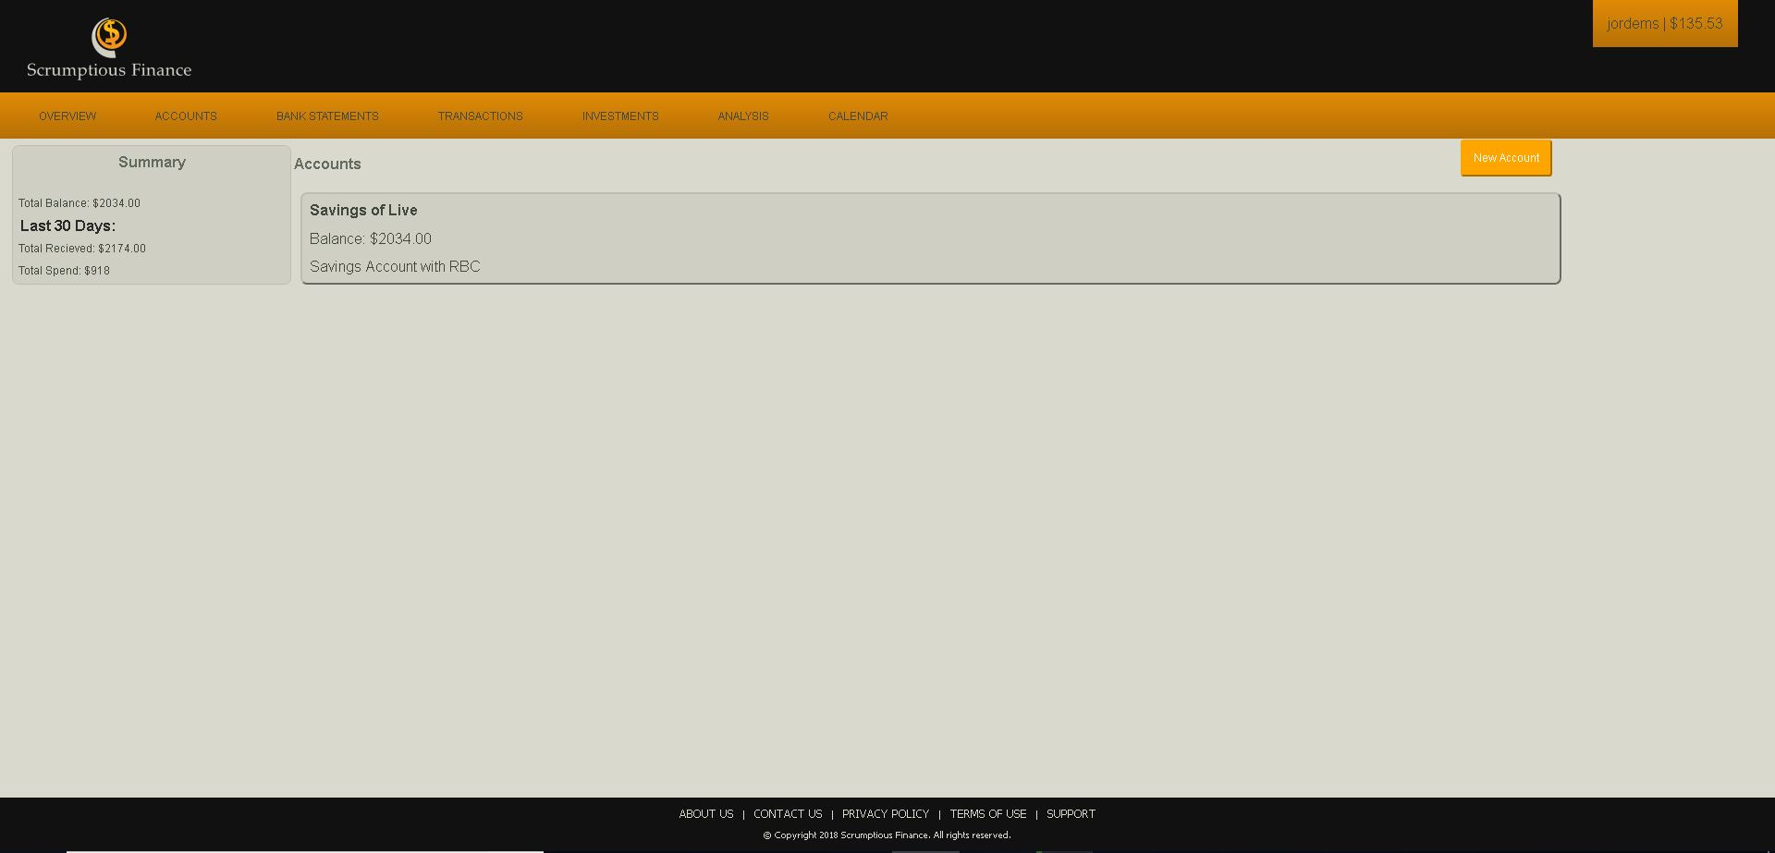

Create Account
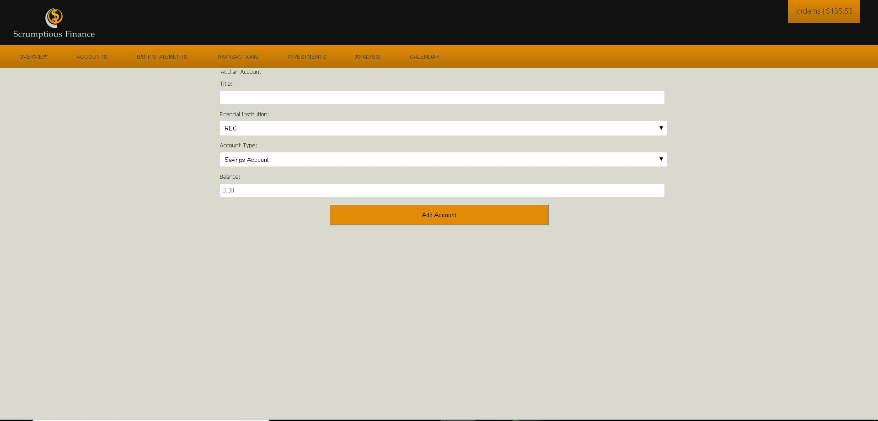

Add Bank statement
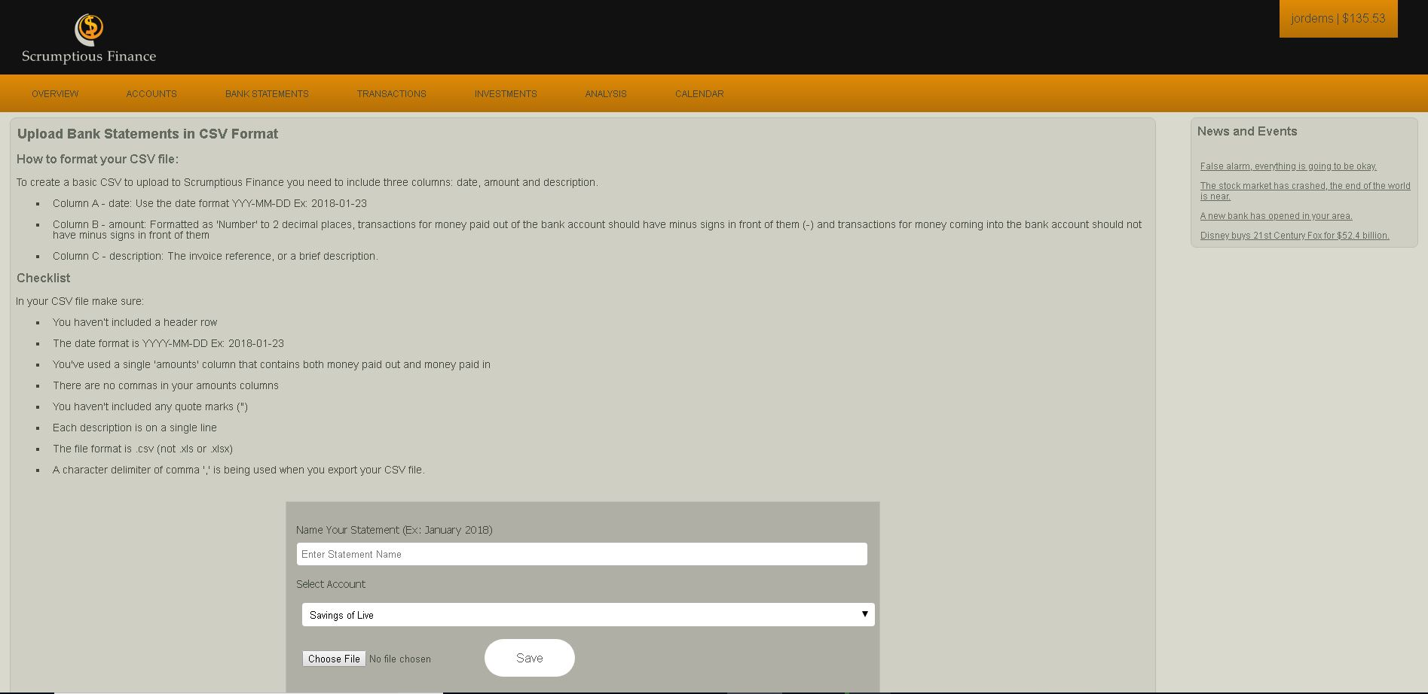

Account overview
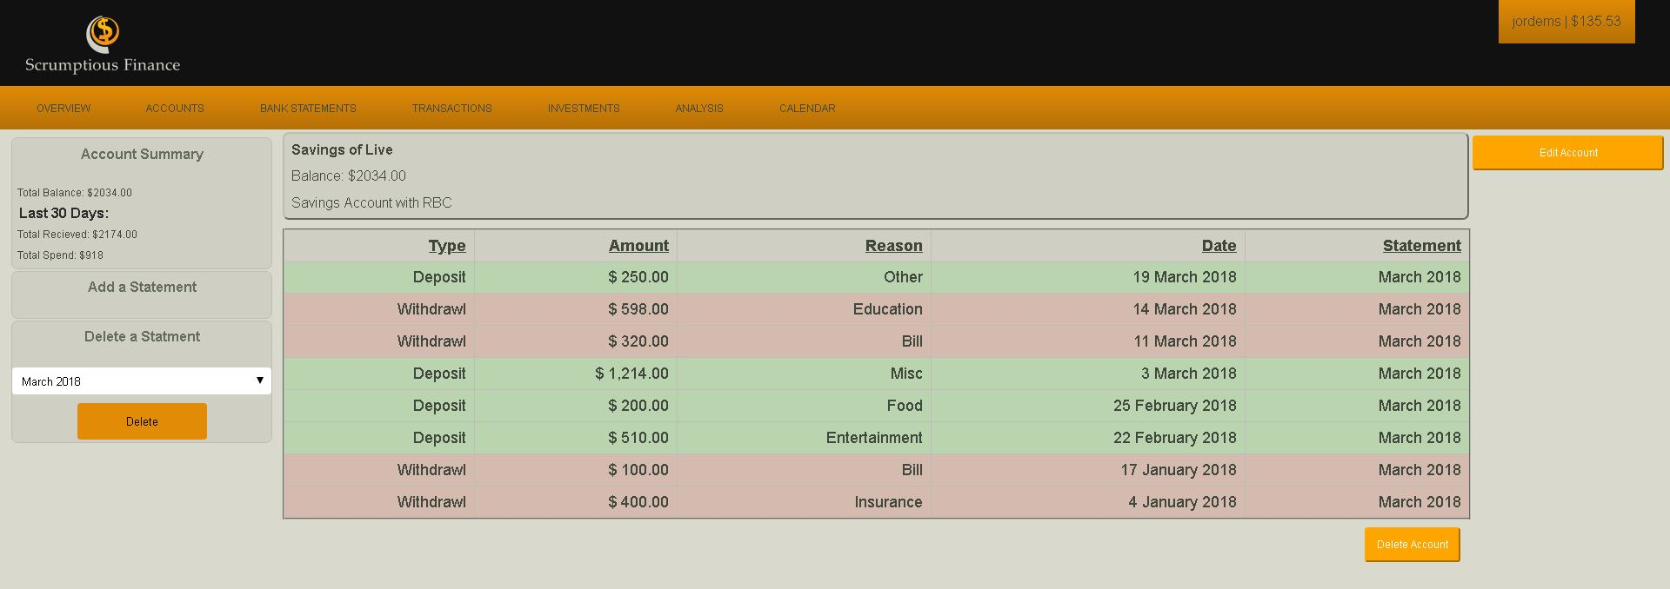

Transactions page 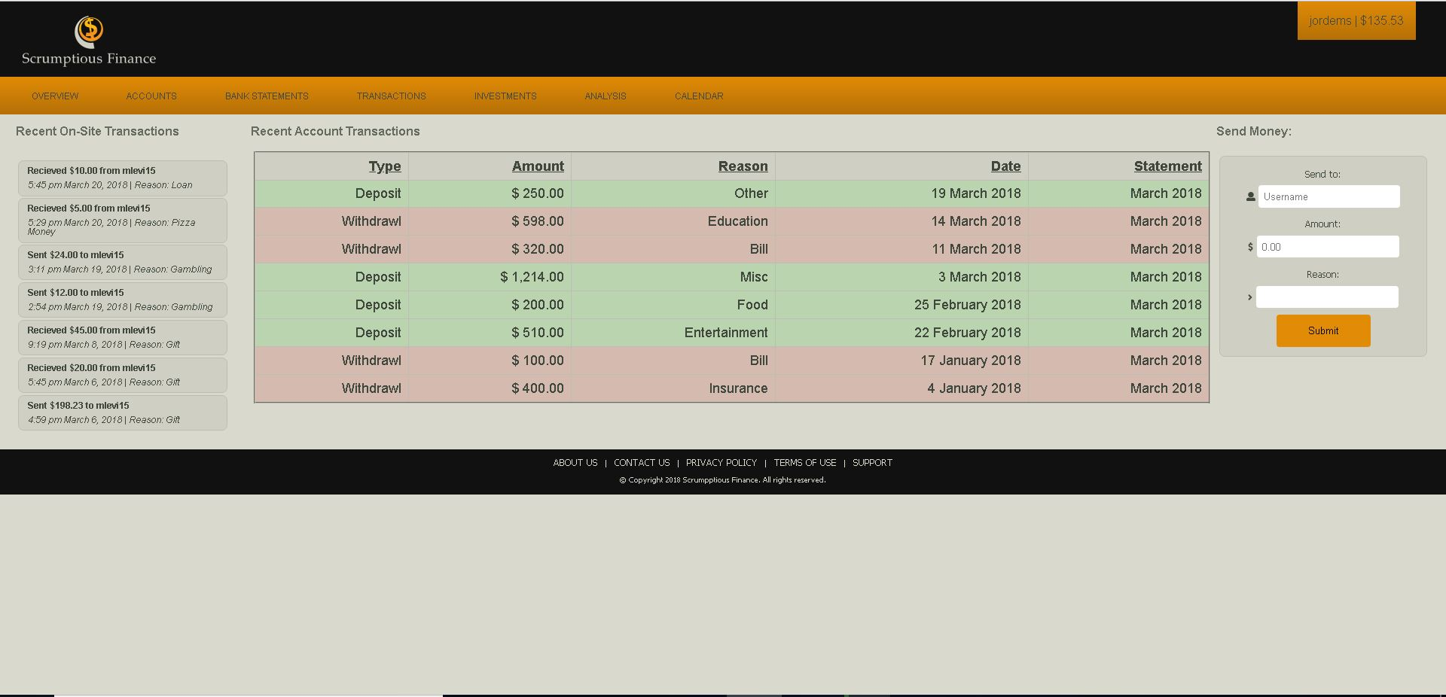

Analysis page
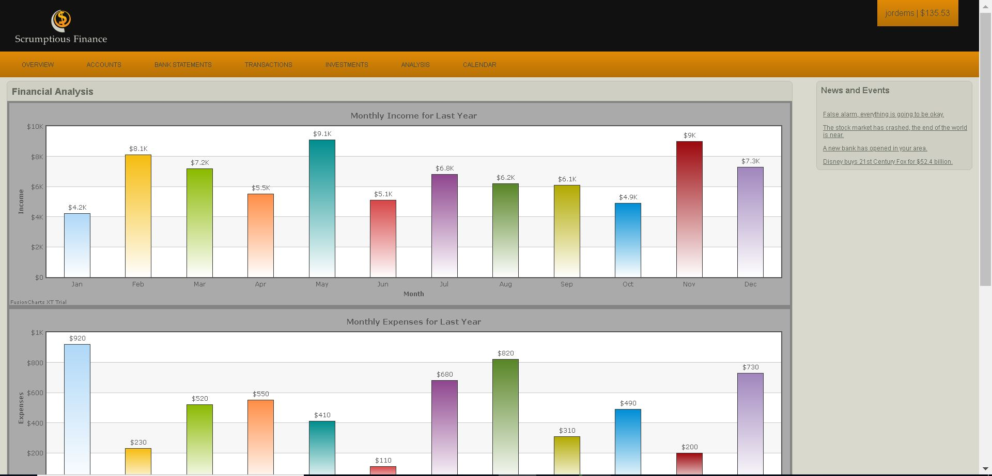

Investments page
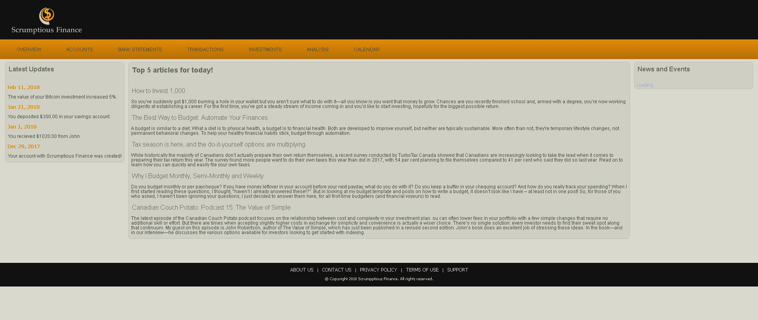

Calendar/Shedule
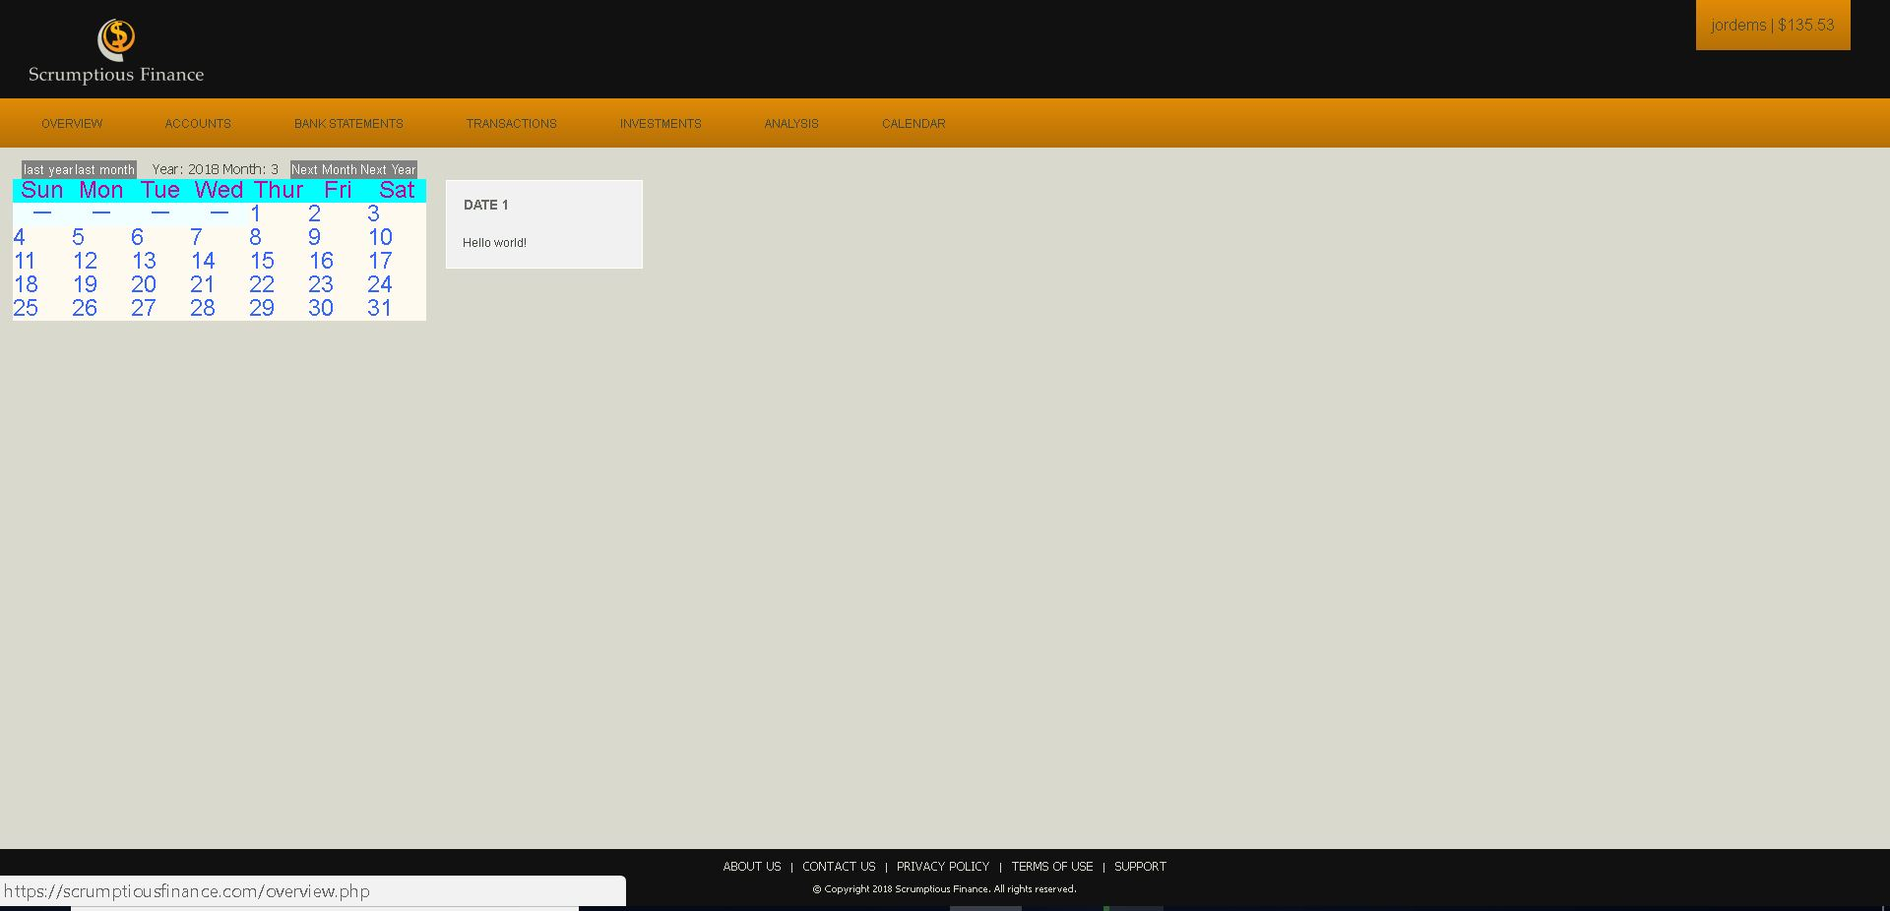

Non-Functional Requirements

Performance Requirements
The major performance requirement for this application is for it to keep the user’s transaction data updated and current by regularly refreshing data on the current account balances and transactions.
The Website shall also need to ensure secure storage of each user’s information and provide the ability for the users to securely send money through the platform to another financial institution.

Security Requirements
Security is a very important aspect of this application and must therefore be treated as such. The two main aspects of this will be: user identification and secure storage of user data.
Regarding user identification, two factor authentications will be used consisting of both a password and a one-time access key (later revisions should look towards a biometric authentication level. These two forms of security will therefore ensure that the user’s identity is verified before they can access any information.
In terms of Data storage, all data will be encrypted and stored on the server for maximum security.

Software Quality Attributes
The software must be designed with the overarching goal of ease of use and strong functionality in mind.
To accomplish this the website shall need to be adaptable and scalable for different screen sizes ranging from 24-inch desktop computer to a 5-inch phone screen. The layout must be straightforward with a professional color scheme and no distracting pop-ups/ads.
In addition to this the website must be functional from a variety of web browsers and platforms which may not have the latest versions of HTML5/Css2.1 installed, therefore the website must be designed with graceful degradation in mind.
Lastly the website must be easily maintainable as it may need to be constantly updated.

